GRADE 7 ACCELERATED · UNIT 1 · LESSON 1
Rewriting Numbers in Equivalent Forms
Worksheet 7A.01.01 ANSWER KEY

1. Which strategy will always work to rewrite a fraction as a decimal? Fill in one bubble.
○ Multiply or divide by 100.
● Divide the numerator by the denominator.
○ Create an equivalent fraction with a denominator of 100.
○ Use the place value of the last digit to determine the denominator.
Dividing always works. Making an equivalent fraction with a denominator of 100 works for 17/20, but not for 1/3 — no whole number times 3 equals 100. Multiplying or dividing by 100 moves between decimals and percentages, not fractions.
2. Which strategy will always work to rewrite a terminating decimal as a fraction? Fill in one bubble.
○ Multiply or divide by 100.
○ Divide the numerator by the denominator.
○ Create an equivalent fraction with a denominator of 100.
● Use the place value of the last digit to determine the denominator.
In 0.85 the last digit is in the hundredths place, so the denominator is 100 and the fraction is 85/100, which simplifies to 17/20. A denominator of 100 works for any decimal that stops at or before the hundredths place — 0.8 is 80/100 as well as 8/10.
For questions 3 through 5, write each fraction as an equivalent decimal. Use bar notation for any decimal that repeats. Then fill in one bubble.
3. |  | = 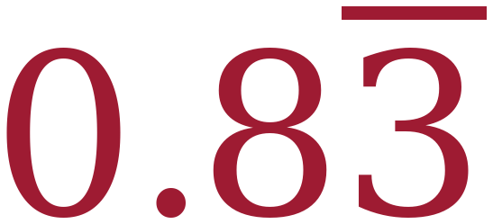
This is a ○ terminating decimal ● repeating decimal.
4. | 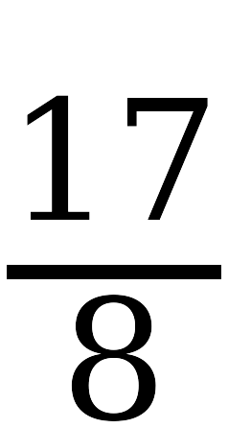 | = 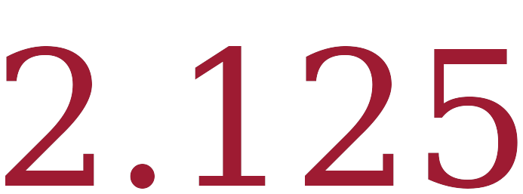
This is a ● terminating decimal ○ repeating decimal.

5. | 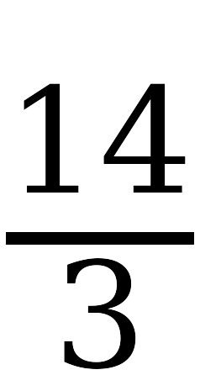 | = 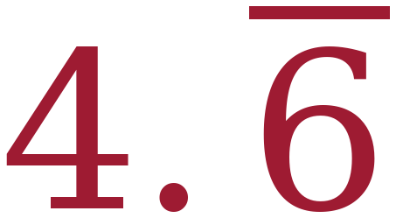
This is a ○ terminating decimal ● repeating decimal.
5 ÷ 6 = 0.8333…, so only the 3 repeats. 17 ÷ 8 = 2.125 exactly, so it terminates. 14 ÷ 3 = 4.666…, so the 6 repeats.
6. The decimal equivalent of 28/15 is 1.86666… . Which of these is 1.86666… written in bar notation? Fill in one bubble.
○ A. | 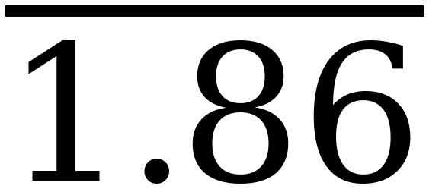

○ B. | 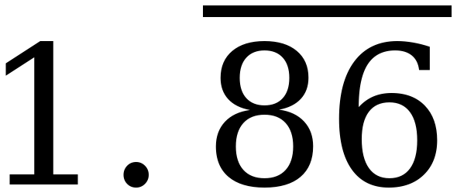

● C. | 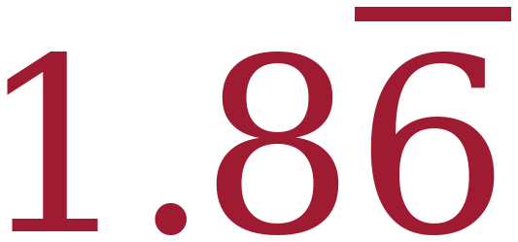

○ D. | 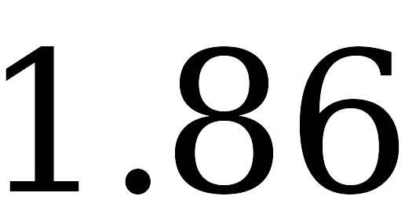
Only the 6 repeats: 28 ÷ 15 = 1.8666…, so the bar goes over the 6 alone. B would mean 1.868686… D is 1.86 exactly, a different number. A puts a bar over the whole number, which bar notation never does.
7. |  | = 
1 ÷ 9 = 0.111…
Use your answer to question 7 for questions 8 through 10. Predict each decimal equivalent, then check it with your calculator. Use bar notation for every repeating decimal.
8. | 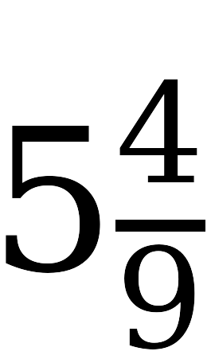 | = 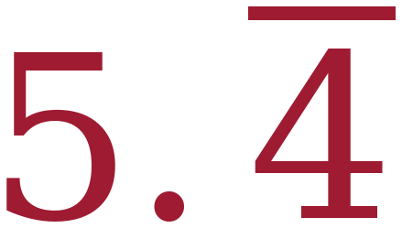

9. |  | = 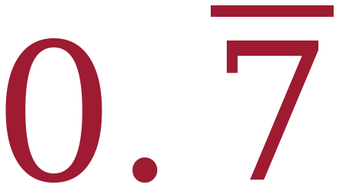
In ninths the numerator is the digit that repeats. 4/9 = 0.444…, so 5 4/9 = 5.444… 7/9 = 0.777…

10. Use 101/9 for parts a and b.
a. Write 101/9 as a mixed number. 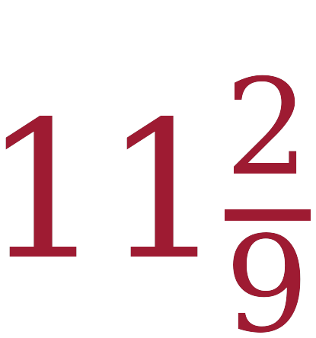
b. Write 101/9 as a decimal. Use bar notation. 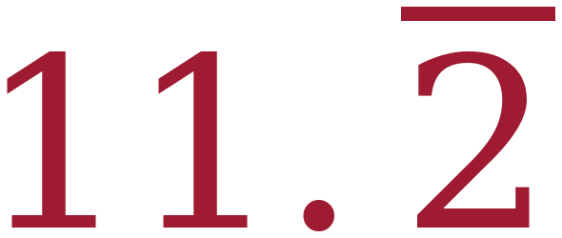
101 ÷ 9 = 11 with a remainder of 2, so 101/9 = 11 2/9. The ninths pattern gives 2/9 = 0.222…, so the answer is 11.222…
11. Priya divides 5 by 9 on her calculator. The screen shows 0.555555556 .
a. Is 5/9 a terminating decimal or a repeating decimal? Fill in one bubble.
○ Terminating.
● Repeating.
b. Write 5/9 in bar notation. 
c. Explain why the last digit on the screen is a 6.
The calculator has room for only ten digits, so it rounds the last one it shows. The true value is 0.5555… and it never stops, so the 6 on the screen is the calculator rounding, not part of the pattern.
Read the pattern from the middle of the display, never from the last digit.

